How does CACFP work?  Day care homes and centers receive money for serving nutritious meals. The Food and Nutrition Service (FNS), an agency of the U.S. Department of Agriculture (USDA) oversees CACFP.  States approve sponsors and centers to operate the program. States also monitor and provide training and guidance to make sure CACFP runs right.  Sponsoring organizations support day care homes and centers with training and monitoring. All day care homes participate in CACFP through a sponsor. |  |  | CACFP Partners  Sponsoring  Organization  Day Care  Home  Sponsored  Center  FNS Regional Office  Independent  Center  State Agency  FNS Child Nutrition  Programs  Your Local Sponsoring Organization  CASEWV—FDCFP  307 Federal St. Suite 410  Bluefield, WV 24701  1-877-715-6401  or 304-324-0453  FNS-319  October 2019  USDA is an equal opportunity provider, employer and lender. |  |  | Building for  The Future  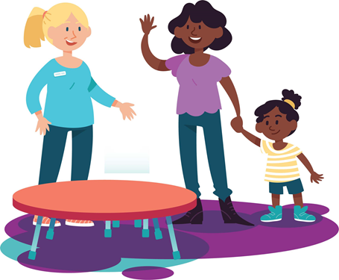  In the  Child and  Adult Care  Food Program  (CACFP)
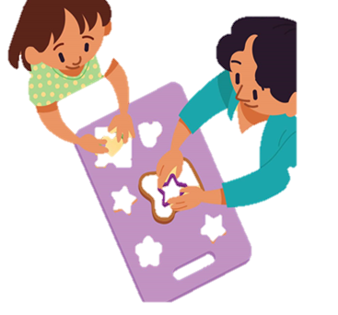
What is CACFP?  CACFP is the Child and Adult Care Food Program. It is a Federal program that pays for healthy meals and snacks for children and adults in day care.  CACFP improves the quality of day care. It makes the cost of day care cheaper for many low-income families.  Besides providing meals in day care, CACFP makes afterschool programs more appealing to at-risk children and youth. Serving afterschool meals and snacks attracts students to learning activities that are safe and fun.  Children and youth who are homeless can also receive meals at shelters that participate in CACFP.  State Agency Director:  Amanda Harrison  WV Dept. of Education  Office of Child Nutrition  1900 Kanawha Blvd, East R-248B  Charleston, WV 25305  304-558-3396 |  |  | Who is eligible for CACFP meals?  - Children under age 13,  - Migrant children under age 16,  - Children and youth under age 19 in afterschool programs in low-income areas,  - Children and youth under age 19 who live in homeless shelters, and  - Adults who are impaired or over age 60 and enrolled in adult day care  What kinds of meals are served?  CACFP meals follow USDA nutrition standards.  - Breakfast consists of milk, fruits or vegetables, and grains.  - Lunch and Supper require milk, grains, meat or other proteins, fruits, and vegetables.  - Snacks include two different servings from the five components: milk, fruits, vegetables, grains, or meat or other proteins. |  |  | Where are CACFP meals served?  Many types of facilities participate in CACFP.  Child Care Centers:  Licensed child care centers and Head Start programs provide day care with meals and snacks to large numbers of children.  Outside-School-Hours Care Centers:  Licensed centers offer before or afterschool care with meals and snacks to large numbers of school-aged children.  Family Day Care Homes:  Licensed providers offer family child care with free meals and snacks to small groups of children in private homes.  “At-Risk” Afterschool Care Programs:  Centers in low-income areas provide learning activities with free meals and snacks to school-age children and youth.  Emergency Shelters:  Homeless, domestic violence, and runaway youth shelters provide places to live with free meals for children and youth.  Adult Day Care Centers:  Licensed centers provide day care with meals and snacks to enrolled adults.

